**DESIGN PHASE FOR THE GLOW UP APP**

**1. Product Overview**

* The **GlowUp WebApp** is a **multi-salon booking platform** that allows users to book appointments with different salons.
* Salons have their own accounts to manage schedules and services.

**2. User Interaction & Flow**

* **Clients**: Browse salons, book appointments, cancel/reschedule, rate services.
* **Salon Owners**: Manage bookings, update services, assign staff, view reports.
* **Admins**: Oversee system functionality, handle disputes, monitor usage, add and verify salons.

**3. Key Features & Functionalities**

* **User Registration & Authentication** (Clients & Salons)
* **Salon Profile Management** (Salon details, services, pricing, images)
* **Appointment Booking System** (Real-time availability, rescheduling, cancellations)
* **Payment Processing** (Optional: Cash/Card integration)
* **Notifications & Reminders** (Email/SMS for bookings)
* **Review & Rating System** (Clients rate salons)
* **Admin Panel** (User management, reports, system logs)

**4. Constraints & Challenges**

* **Multi-salon hosting**: Each salon must have its own independent profile and booking system.
* **Scalability**: Handling multiple bookings, salons, and users without slowdowns.
* **Security & Privacy**: Protecting user data and transactions.

**5. Wireframes & Diagrams**

* **Use Case Diagram**

* **Class diagram**

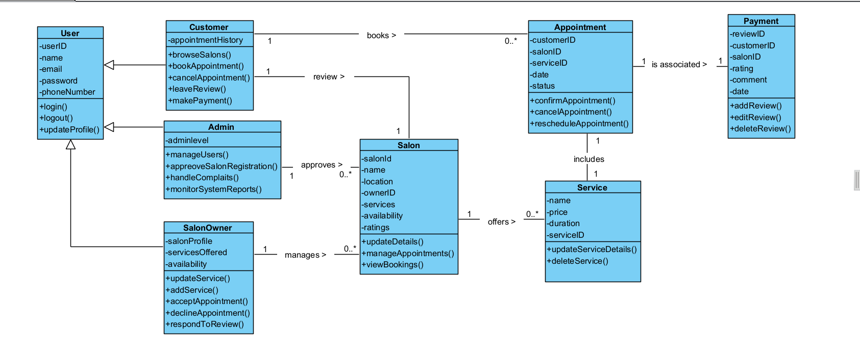

* **Sequence diagram**

Managing appointmets

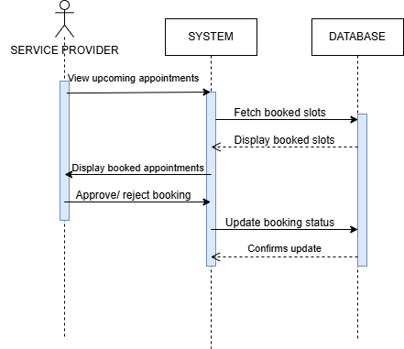

Adding Services

User Registration

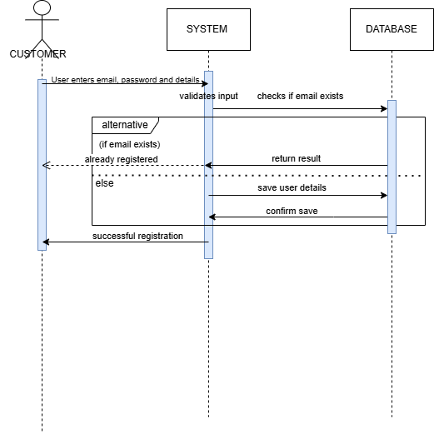

approve or reject bookings

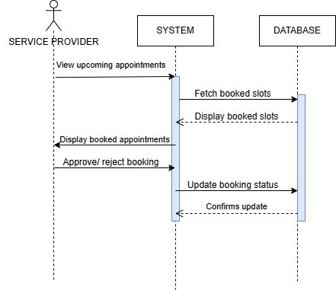

* **Activity diagram**

**Making Payment**

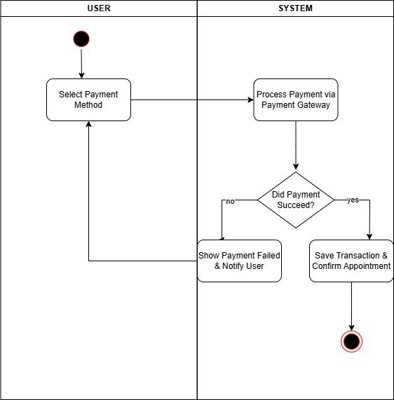

Checking availability

**Key Wireframes Needed for GlowUp WebApp**

Since the website hosts multiple salons, we’ll need wireframes for:

* **Landing Page** – A homepage with a search bar for salons, featured salons, and a login/signup button.

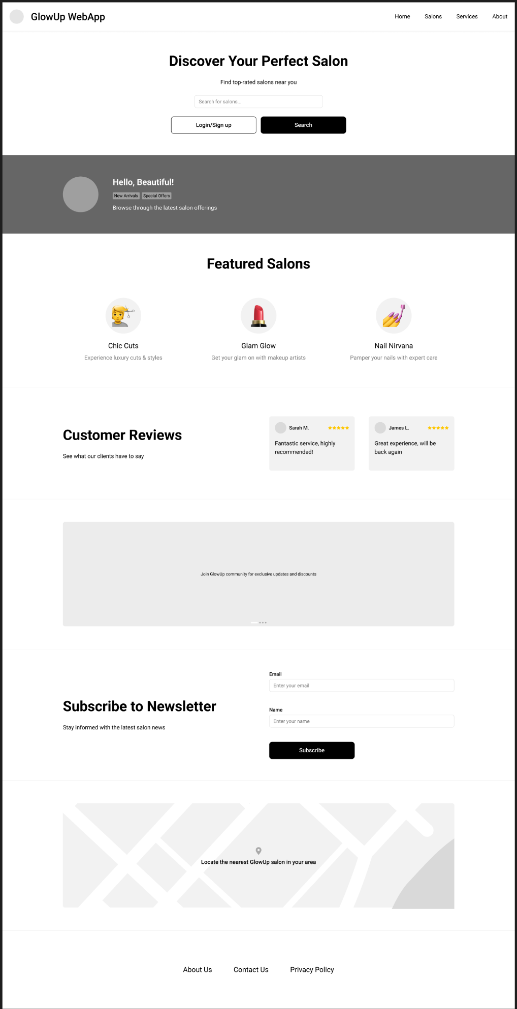

* **Booking Page** – A form where customers select a date, service, and confirm their appointment.

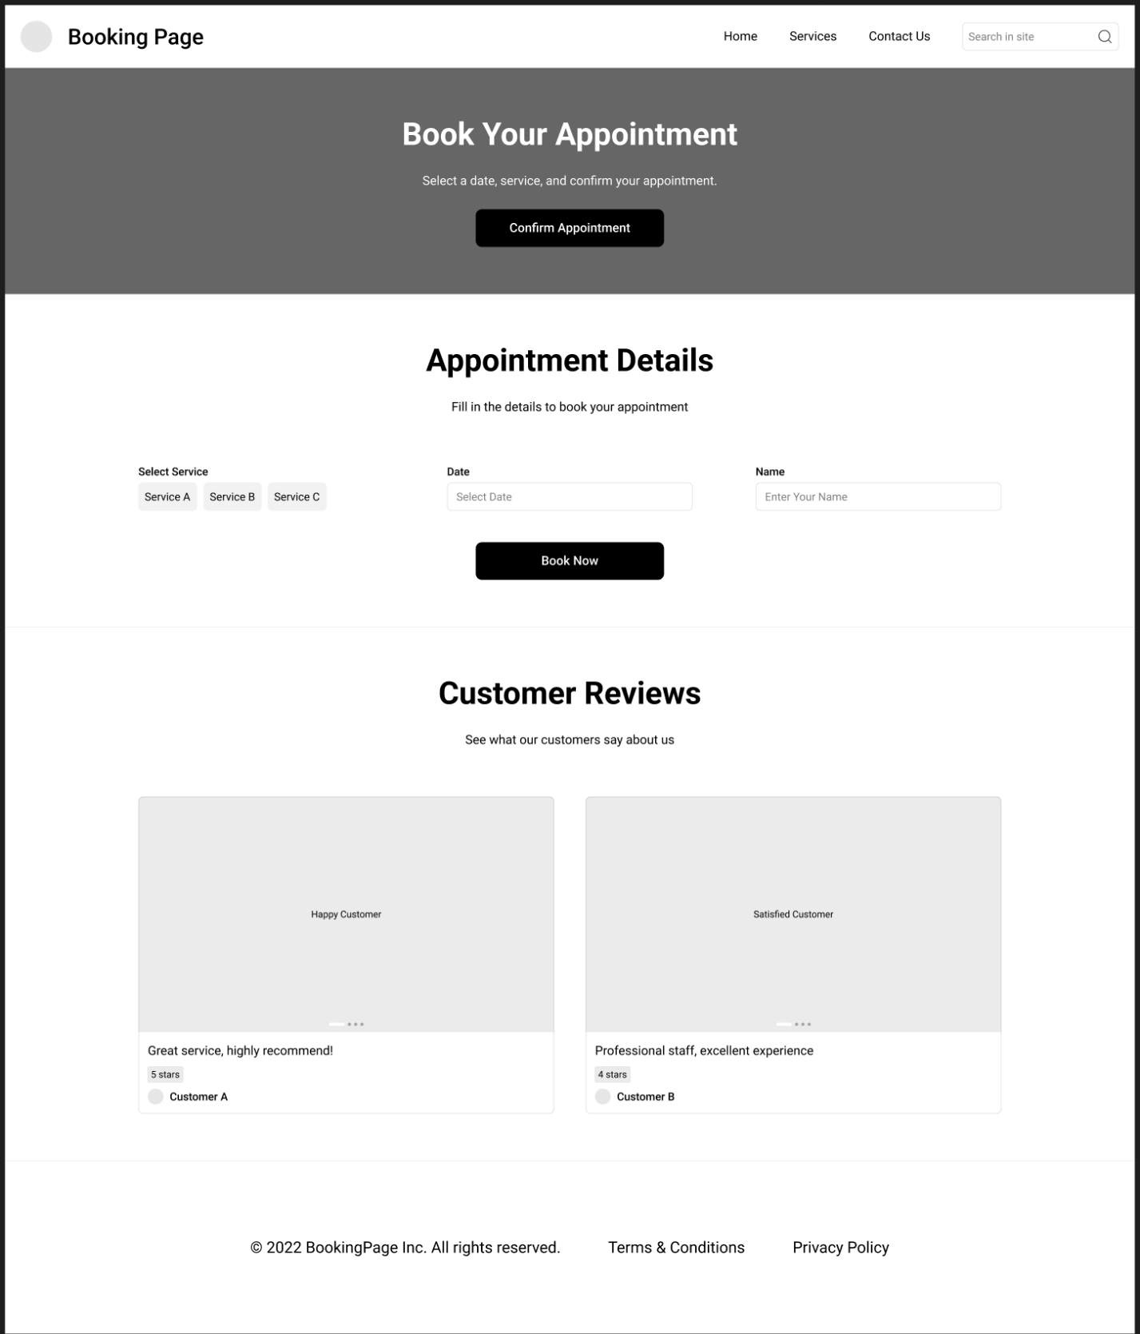

* **Salon Listing Page** – Displays all registered salons with filters (location, services, ratings, etc.).

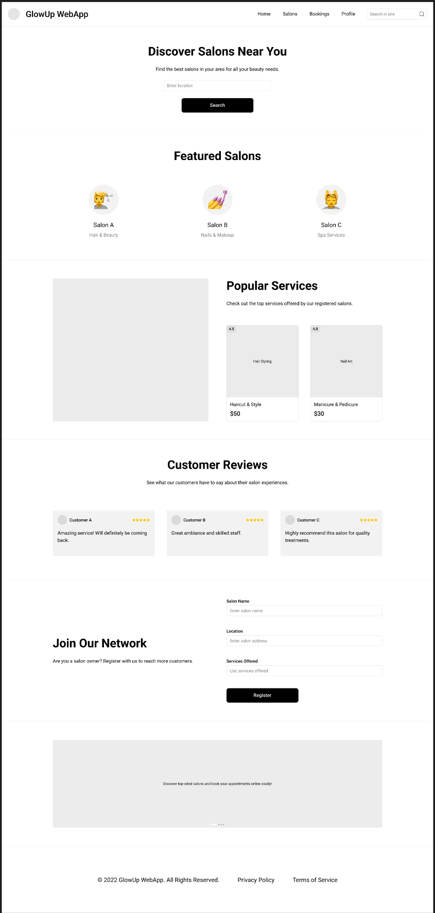

* **Salon Profile Page** – Each salon's individual page with details (services, pricing, images, availability, and booking option).
* 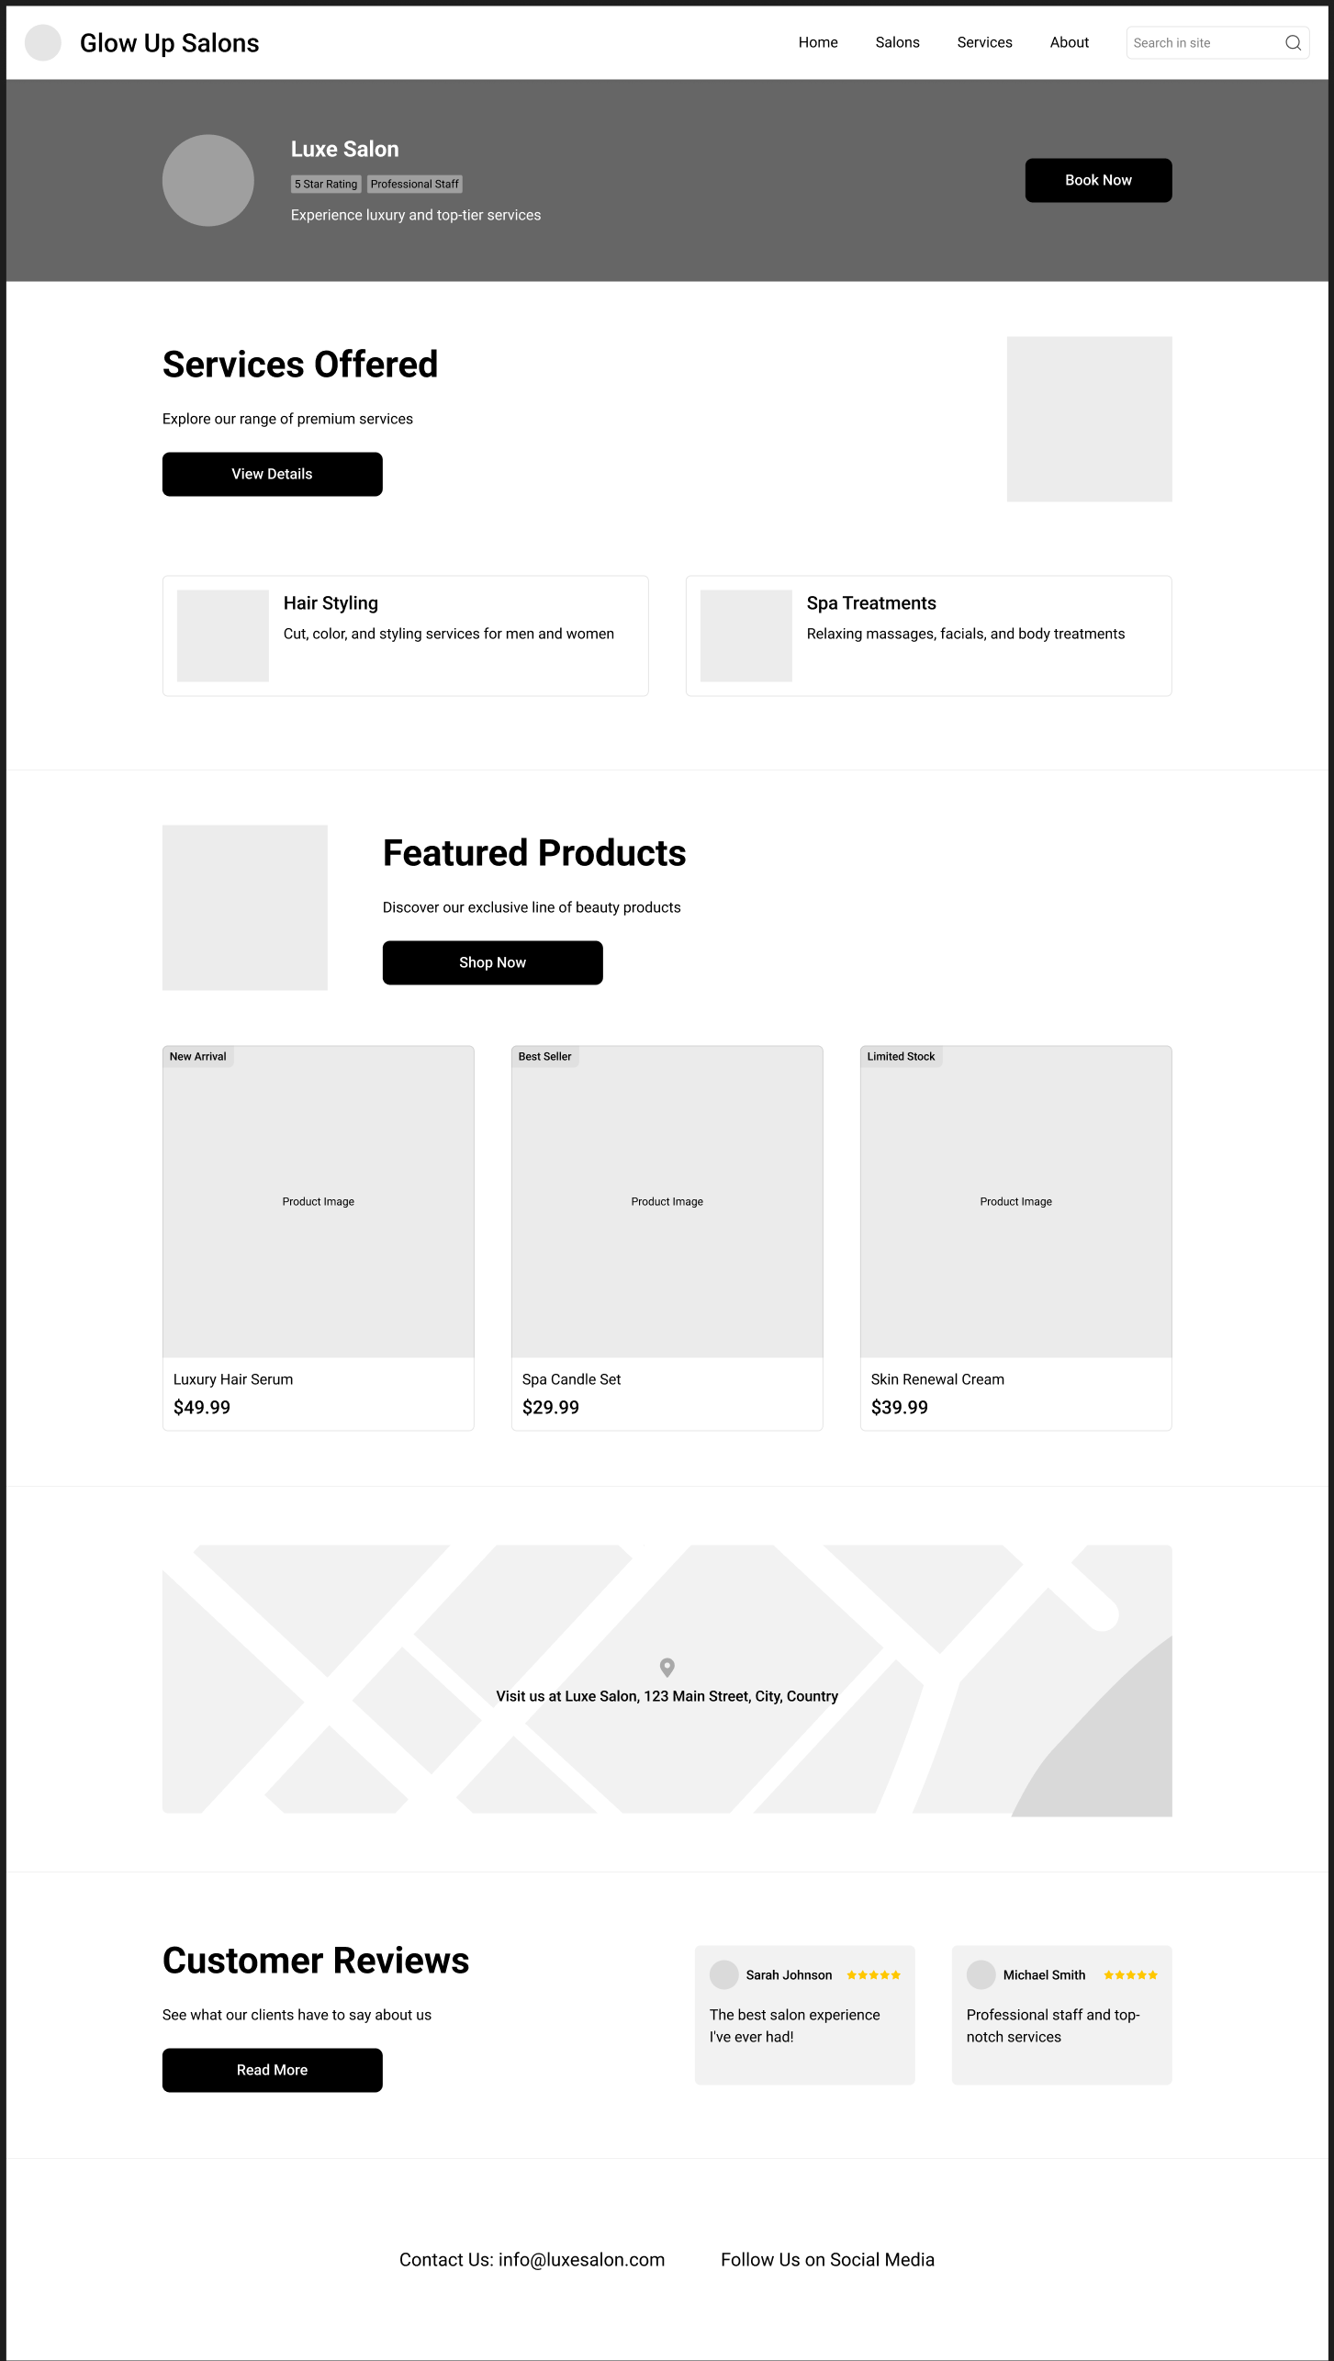
* **Customer Dashboard** – Shows upcoming bookings, past appointments, and options to manage bookings.
* A screenshot of a computer screen

  AI-generated content may be incorrect.
* **Salon Owner Dashboard** – Allows salon owners to manage their business, update services, view bookings, and set availability.
* 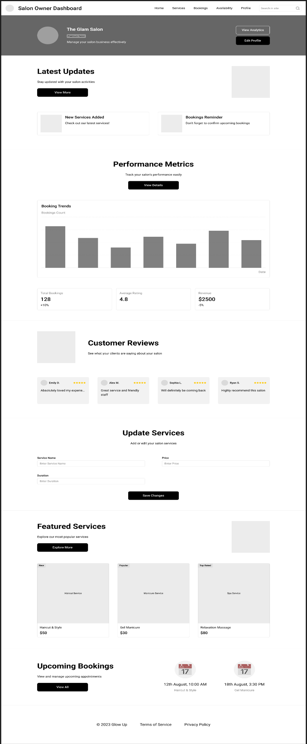
* **Admin Panel** – For managing salons, users, and overall platform settings.

